Date | 03 October 2026
Team ID | SWTID-2026-7735
Project Name | Auto Ticket Classification using Flow Designer
Maximum Marks | 4 Marks

Ideation Phase
Brainstorm & Idea Prioritization Template
Brainstorm & Idea Prioritization Template:
Brainstorming provides a free and open environment that encourages everyone within a team to participate in the creative thinking process that leads to problem solving. Prioritizing volume over value, out-of-the-box ideas are welcome and built upon, and all participants are encouraged to collaborate, helping each other develop a rich amount of creative solutions.
Reference: https://www.mural.co/templates/brainstorm-and-idea-prioritization
Step-1: Team Gathering, Collaboration and Select the Problem Statement
The school IT helpdesk receives multiple incident requests daily from students and teachers, such as Wi-Fi issues, projector failures, password problems, and slow computers. Currently, IT staff manually reviews each request and assigns a category, which is time-consuming and inefficient. This project automates ticket classification using ServiceNow Flow Designer by analyzing keywords in the incident's short description and description fields.
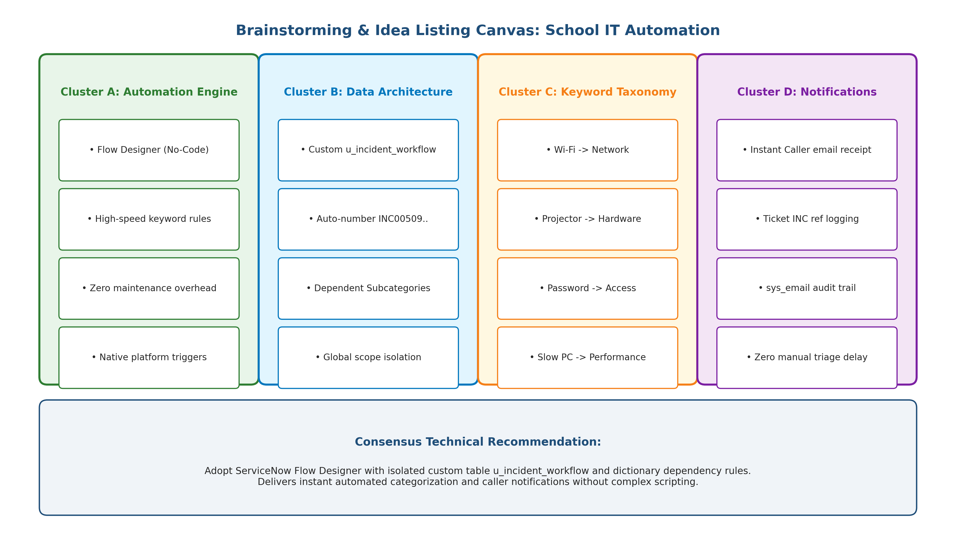
Figure 1.1: Brainstorming Workshop Idea Listing & Architectural Clustering Canvas
Step-2: Brainstorm, Idea Listing and Grouping
During the ideation workshop, potential technical mechanisms were categorized into 4 operational clusters: (A) Automation Engines (Flow Designer vs Business Rules vs ML); (B) Custom Data Store (Isolated Table u_incident_workflow vs OOB Incident); (C) Taxonomy & Dependent Choices; (D) Notification Services.
Step-3: Idea Prioritization
Ideas were prioritized on a Value vs. Complexity matrix to maximize immediate student and teacher satisfaction with zero maintenance complexity.
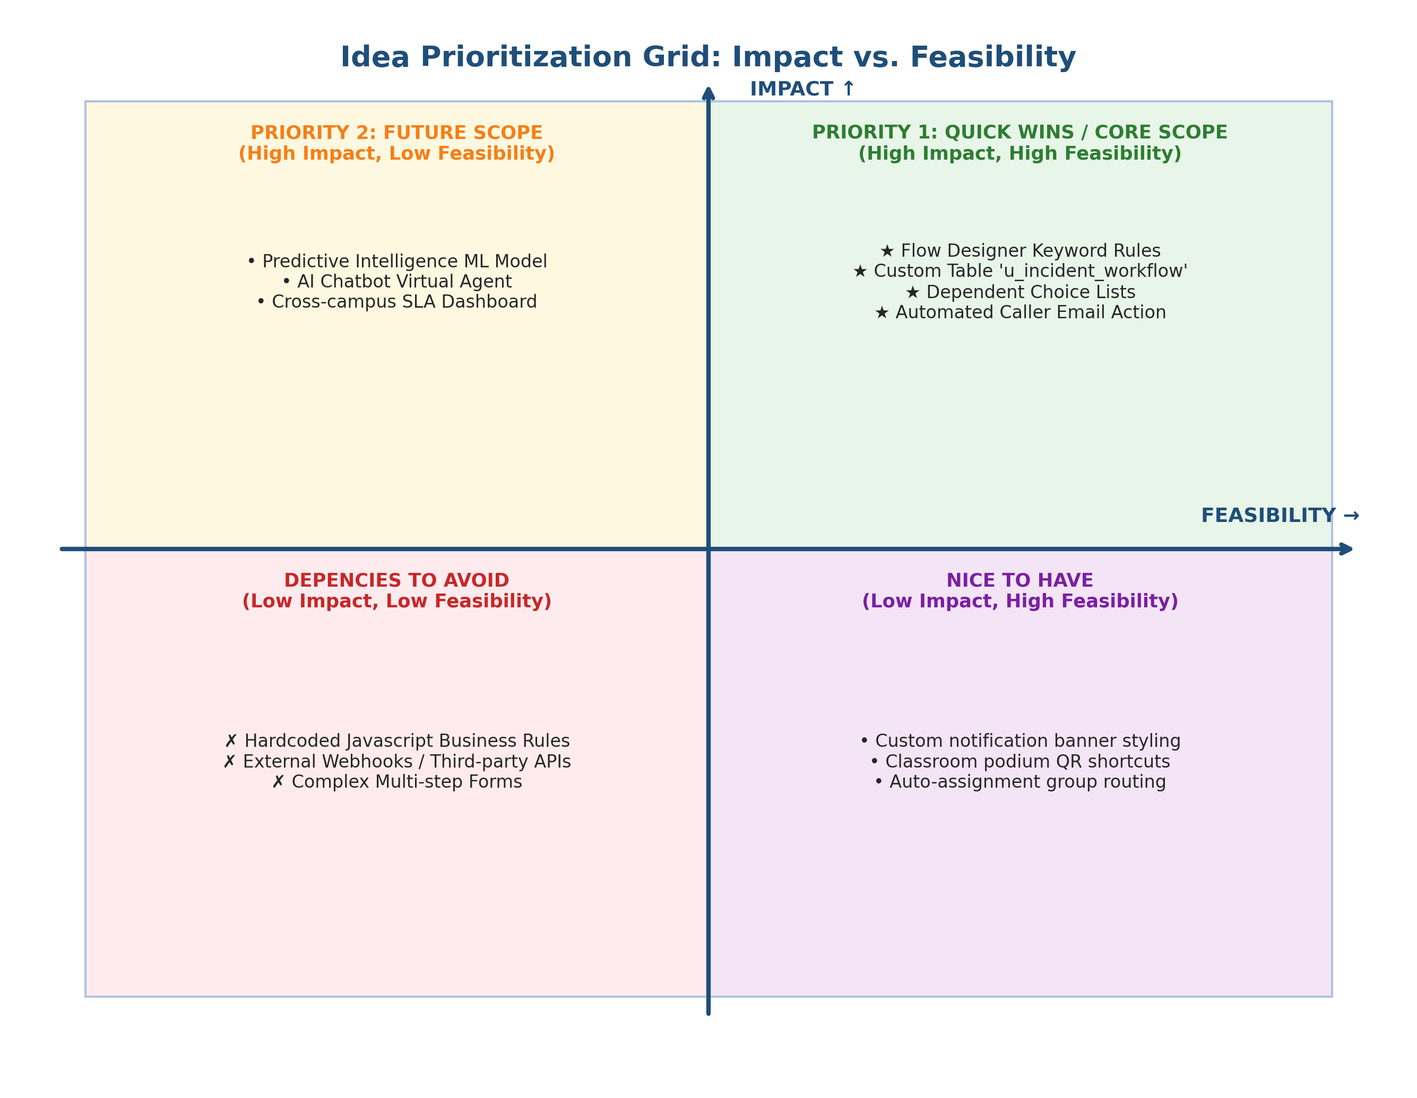
Figure 1.2: Idea Prioritization Matrix (Impact vs. Feasibility)
Idea / Solution Concept | Feasibility | Impact | Complexity | Prioritization Decision
Flow Designer Keyword Logic (Wi-Fi, Projector, Password, Performance) | High | High | Low (No-Code) | P1 - Core Scope (Must Have)
Custom Table 'Incident WorkFlow' with Auto Numbering | High | High | Low | P1 - Core Scope (Must Have)
Dictionary Dependency (Category -> Subcategory) | High | High | Low | P1 - Core Scope (Must Have)
Automated Flow Designer Caller Email Confirmation | High | High | Low | P1 - Core Scope (Must Have)
Predictive Intelligence / ML Model Auto-Triage | Medium | High | High (Requires Pro license) | P3 - Future Scope (Post MVP)

